Edison G. Velez Martinez

COMP4018

Marko Schutz-Schmuck

Project: Airsoft DBMS

**Introduction**

Airsoft is an extreme sport, similar to paintball, in which players eliminate opposing players by firing 6mm plastic projectiles, known as “BBs”, using non-lethal replica weapons called airsoft guns. The main differences that set it aside from paintball are:

* The projectiles (BBs) are solid plastic spheres, they do not mark or paint a player upon impact unlike paintballs do. These BBs are 6mm in diameter (although there are the uncommon 8mm ones), and are classified by weight varying from 0.20g up to about 0.60g (common upper bound is about 040g). Airsoft uses an honor based system in which eliminated players must “call their hits” and acknowledge that they are out, regardless of being seen or not. Airsoft BBs are also a lot cheaper than paintballs. Your average bag of 500ct paintballs will cost about $15. With that same amount of money you can purchase a 5000ct BB bottle. That’s 10 times the ammo for the same price, not to mention what you spend on CO2/HPA gas tank fills.

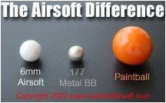

* Airsoft guns are realistic replicas of real steel guns, usually on a 1:1 scale or close, and are magazine fed. Paintball guns, called markers, are generally easily distinguishable from real firearms as they are differently shaped and colored, have a CO2 or HPA tank attached as a power source, and are hopper fed. There are some paintball marker that somewhat resemble real firearms but are more easily distinguished by the gas line and the hopper.

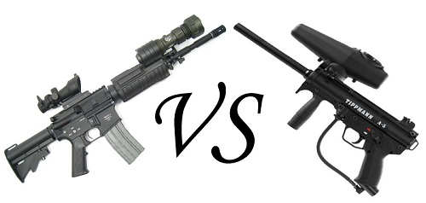

* Airsoft is generally more oriented towards military simulation style gameplay. Airsoft players will usually wear camouflage uniforms and military gear, along with their realistic replica guns. The game experience and dynamic is also a lot more tactical and strategic, and there’s a lot more variety of gametypes in which one can participate. While you will find groups of people that play similar types of paintball game types, the most common one consists of players trying to quickly eliminate the opposing team taking cover behind inflatable structures and peeking out to fire at the enemy, it’s a lot more fast-paced and aggressive play style.

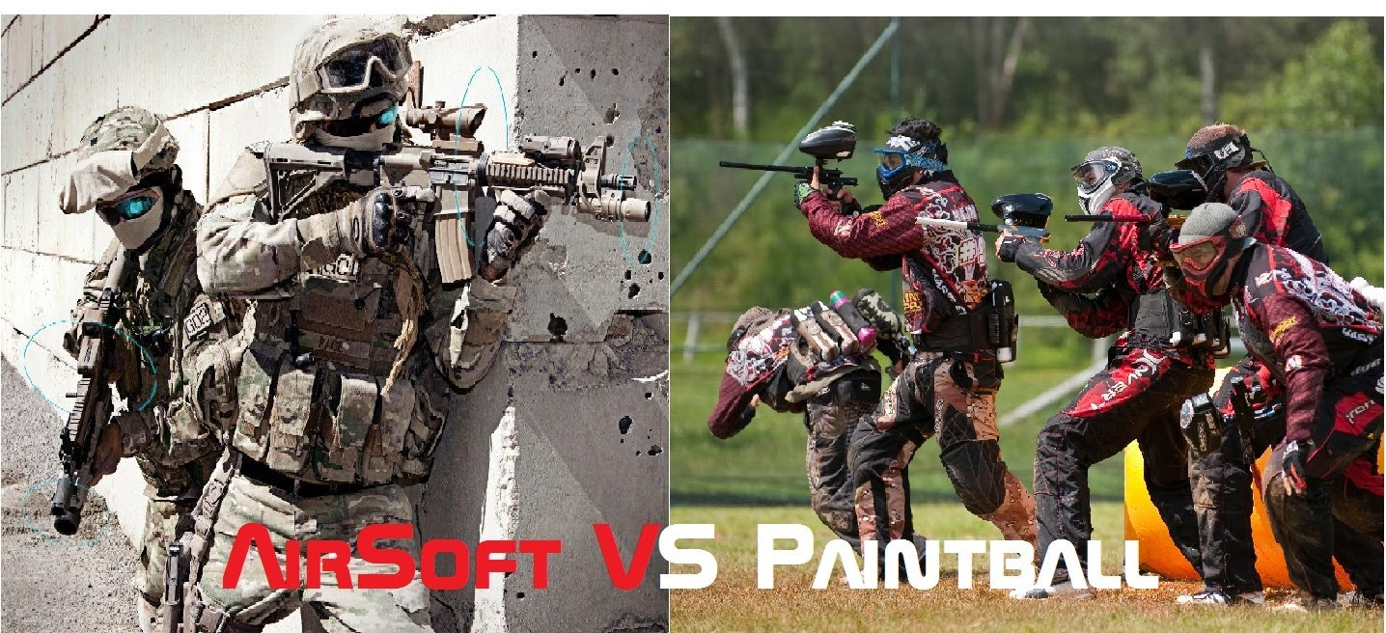

This short but detailed comparison should explain the key differences between the sports and and give you a basic idea of how it plays out. While there are various game types that can be played, some rules and guidelines apply to all of them. In most game types you will have two teams trying to eliminate each other until every no members of the opposing team are remaining. Rules for these can vary, as you may have multiple lives per game or only one, or you may have players take a medic role to revive other players. Some game types include having to capture or destroy an objective, while eliminating the enemy team. These type of games are considered the standard type of game style. There’s no fixed set of rules to the games, they will depend on where and who is playing, which also determines fps limits. The only fixed rules are: call your hits, be polite, respect others, and have a good time. Cheating will get you banned and give you bad reputation among the community. Aside from the standard game style, there is also the MilSim (military simulation) style community. This takes airsoft to the next level of realism/simulation, playing well planned out and specific scenarios, missions that lasts usually 2 or 3 days, and make use of buildings and fields that have been adapted to recreate the scenario. There are also rules and constraints that affect a player's loadout, such as scenario specific weapons or clothing, low capacity magazines, and physical health status. I will explain some of the essential aspects of airsoft guns in the following paragraphs.

**Airsoft Guns**

Airsoft guns are modeled after real steel weapons and are generally almost, if not completely, 1:1 in terms of dimensions. They are usually made out of metal, or durable polymer plastic, this depends on the model and the manufacturer. Some manufacturers have what they call “proline” and “sportline” models, the proline usually being higher quality, with metal bodies, better details, and slightly better out of the box performance, while the sportsline are similar in performance, but are usually made out of strong polymer plastic. There are different kinds of airsoft gun categories, based on their design and function, which follow real steel classification. It is also worth noticing that some airsoft guns are classified into a certain category based on their propulsion system/power source, which is generally referred to as their type. Propulse system aside, the other key components that make an airsoft gun fire effectively are the hop up unit, and the inner barrel. The hop up unit, contained in the hop up chamber, is the system that applies backspin to the airsoft BB, so that it may travel accurately once it exits the inner barrel. Just like in real guns, the inner barrel is what guides the airsoft BB as it is pushed out by the air or gas that powers it. The right combination of hop up unit and inner barrel, along with proper tuning, is what will determine how far and how accurate the BB travels. Too much hop, and the BB will curve upwards, not enough and it will drop before it reaches it’s target. It’s important to find the sweet spot depending on the BBs being used, and the force with which it is shot out. The force with wich a BB si fired is measured in Joules, while the velocity usually is measured in FPS (feet per second) in the US and western countries, or MPS (meters per second) in Europe and eastern countries. I will now proceed to explain the different kinds of airsoft guns and their functionality.

**AEG (Airsoft Electric Gun)**

These airsoft guns are powered by batteries, and work using a mechanical system known as a gearbox. The gearbox contains all the moving parts that make the gun function, and is the heart of an AEG. These parts include the gears, piston, cylinder, cylinder head, nozzle, tappet plate, trigger mechanism, anti reversal latch, bearings, spring, spring guide, and the wiring that connects the trigger mechanism to the motor and power source. The motor is usually housed in the pistol grip (also know as motor grip in AEGs), and makes contact with the gearbox when secured in place by adjustable screws in the grip. These parts, depending on their quality/type, and their tuning, will determine the performance of the AEG: how fast it will shoot/cycle, the trigger response, the force with which the BB will be shot, the consistency of the shots, and the functional lifespan of the airsoft gun (things beak, specially if poorly made/cheap, or poorly tuned).

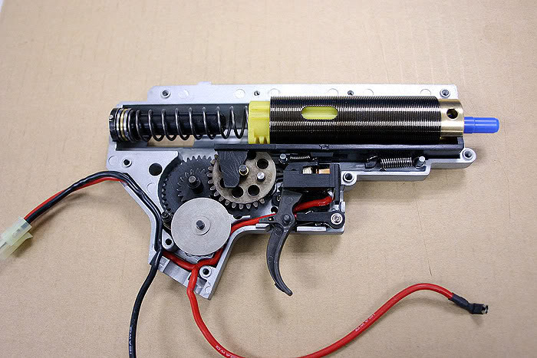

A standard AEG gearbox (opened)

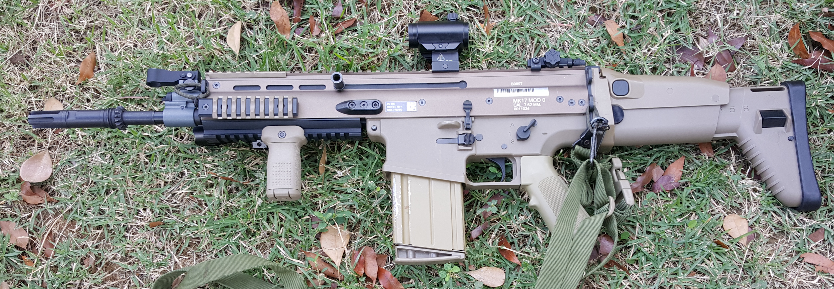

VFC SCAR-H AEG

**Gas Powered - Gas Blow Back(GBB) - Gas Non Blow Back (GNBB)**

These airsoft guns are powered by a type of gas, that usually goes loaded into the magazine. The different kinds of gas used are: green gas/propane (with silicone), CO2, or duster gas. The most common gas is green gas, which is basically propane with silicone, followed by CO2. Green gas is efficient, with decent power, but may suffer from cooldown when fired in low temperatures. CO2 does better in the cold, but tends to shoot “hot” (higher FPS), and comes in small 12g or 16g canisters that are inserted into the magazine. Duster gas is usually reserved to Japan due to FPS/power limit of 1 Joule (about 330 FPS).

GBB guns are gas powered has moving parts that cycle when fired, simulating the action of a real firearm. They also have recoil because of the cycling action, and while the “kick” is not as strong as a real firearm it’s still nice and makes it more fun to fire (at least most people will agree, myself included). Gas rifles and pistols (GBBR and GBBP respectively) are the common types of gas guns. There are also non blowback (GNBB) pistols, and gas powered shotguns and bolt action rifles. These work the same way, but they have now blowback feature, as there is no visually moving parts that replicate the cycling action.

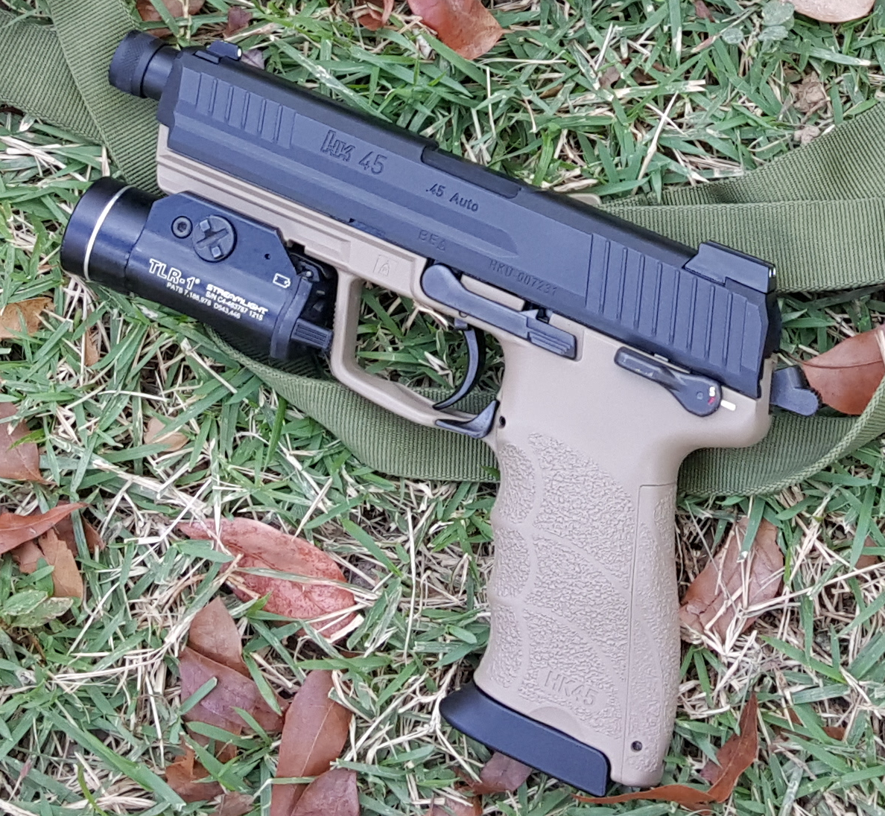

Tokyo Marui HK45 Tactical GBB Pistol (w/ TLR-1 light)

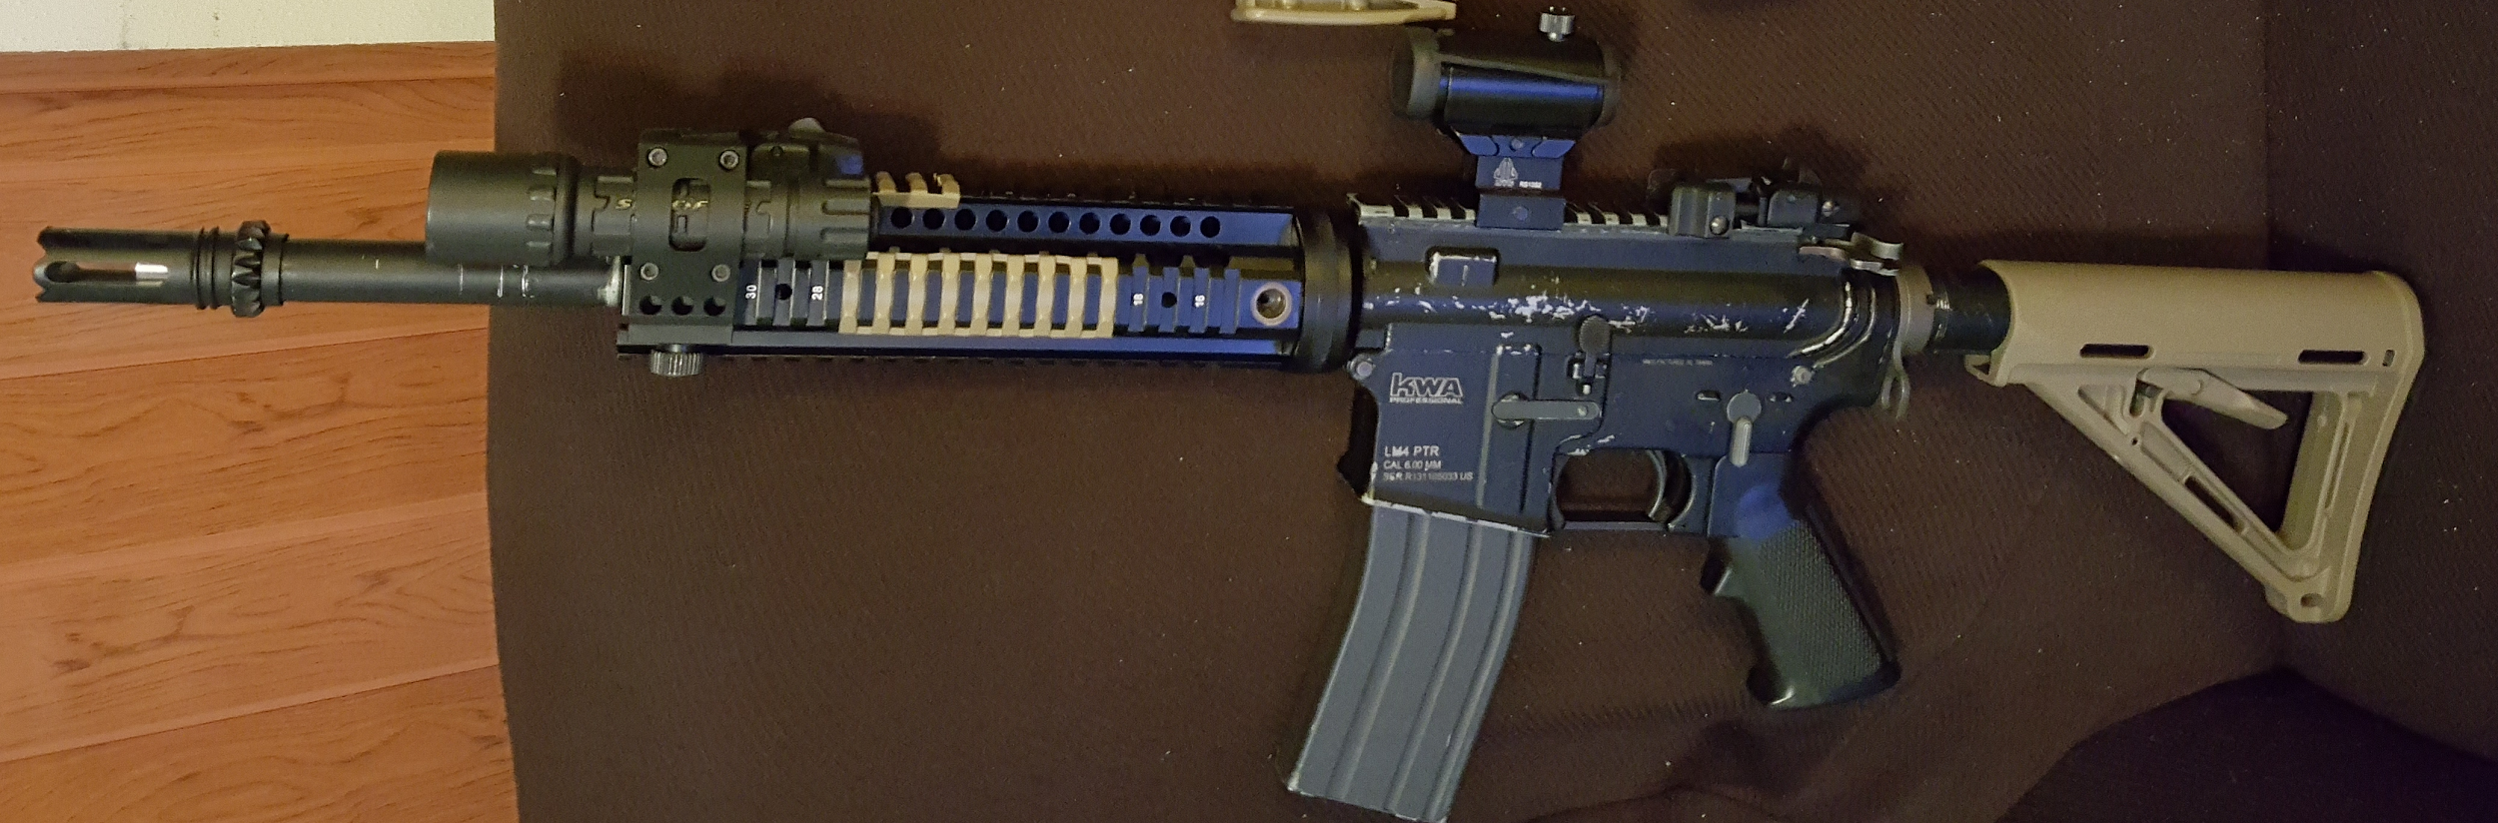

KWA LM4 PTR GBB Rifle (custom)

**Spring powered**

These airsoft guns work by using a spring powered cylinder system that compresses air when cocked, and then expels it when fired. They are the simplest kind of airsoft gun, and they are also the most reliable (less moving parts means less stuff breaking). There’s a noticeable distinction in usability depend on the kind of gun for this type. The bolt action sniper rifles and shotguns are the skirmishable, well performing kind, while the rest tend to be cheap, low powered springer versions of other gun models that normally come as AEGs or GBBs.

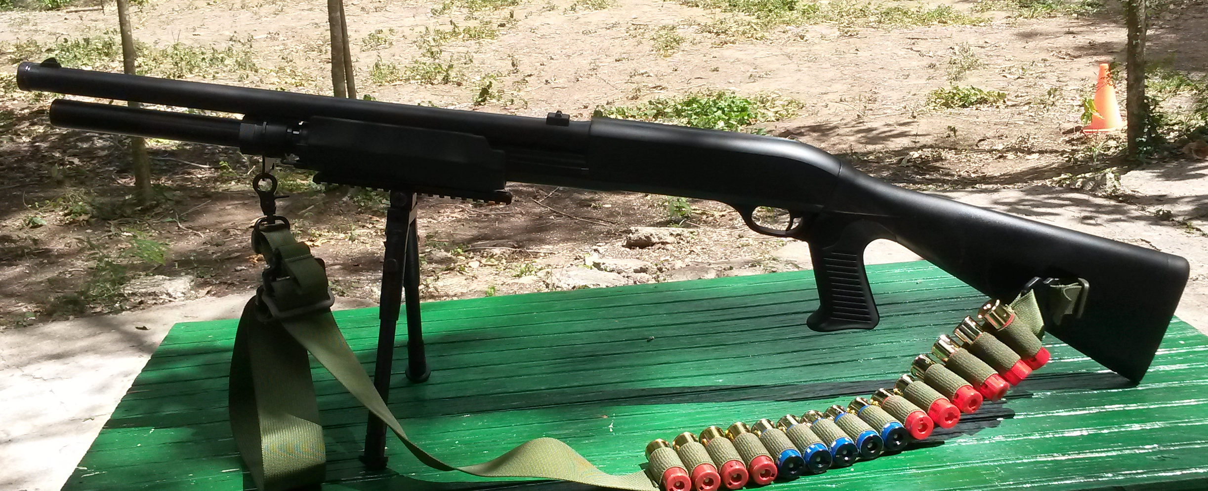

TSD M3 Tri-Shot Pump Action Shotgun

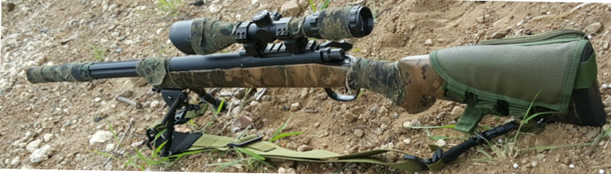

Tokyo Marui VSR-10 Bolt Action Sniper Rifle (custom)

**Schema**

**Team**(name, founder, captain, memberCount, minAge, type, rank)

**Member**(name, town, playerID, teamName, teamCallsign, rank)

**Player**(name, town, playerID, callsign, age, experience, ownershipNum)

**AirsoftGun**(name, brand, model, serialNum, class, type, fps, color, price, ownershipNum, bindID, loadTicketNum)

**Attachment**(name, brand, type, color, price, bindID)

**Loadout**(primGunTickNum, secGunTickNum, topColor, pantColor, gearColor, carrier, headwear, headwearColor, eyewear, facepro, ownershipNum);

**Team**

Each team has their name, the playerID of the founder of the team, the playerID of the captain (leader) which may or may not be the founder, the ammount of members (memberCount), a minimum age requirement for joining (minAge), the type of team (“standard”, “milsim”), and their rank among other teams.

**Member**

Members of a team are players. They have their name, the town from when they’re from, their playerID, the name of the team, a teamCallsign that is different from their personal callsign, and their rank in the team.

**Player**

Players have their name, town from when they’re from, a unique playeID, a personal callsign, their age, the level of experience (“beginner”, “adept”, “veteran”, “pro”), and an ownershipNum for airsoft guns and loadouts.

**AirsoftGun**

Airsoft guns have the specific name for that brand model, the name of the brand (sometimes not same as manufacturer), the model for that gun, the unique gunSerialNum for that gun model, the class to which it belongs (“rifle”, “smg”, “dmr”, “pistol”, “shotgun”, “bolt”, “lmg”), the type of airsoft gun (“aeg”, “gbb”, “gnbb”, “gas”, “spring”), the fps, the color of the gun (ie black, tan, OD, grey, black and tan, etc), the stock price of the gun, and a unique bindID for attachments, and a unique loadout ticketNum.

**Attachment**

Attachments have the specific name of the attachment, the brand name, the type of attachment (“optic”, “rail”, “foregrip”, “grip”, “stock”, “light”, “laser”, “adapter”, “misc”), the color of the attachment, the price, and the bindID for referencing the airsoft gun it is attached to.

**Loadout**

A full loadout consists of a primary gun identified by its ticket number (primGunTickNum), a secondary gun identified by its ticket number (secGunTickNum), the color of the top shirt or uniform (topColor), the color of the pants (pantColor), the color of the gear (gearColor), the type of carrier (“chest rig”, “plate carrier”, “vest”, “harness”, “none”), the headwear (“hat”, “helmet”, “boonie”, “beanie”, “none” ), the headwear color, the eyewear for protection (“glasses”, “goggles”, “mask”), facepro for added protection (“mesh”, “balaclava”, “shemagh”, “mouthguard”, “none”), and the ownershipNum for determining who owns that specific loadout.

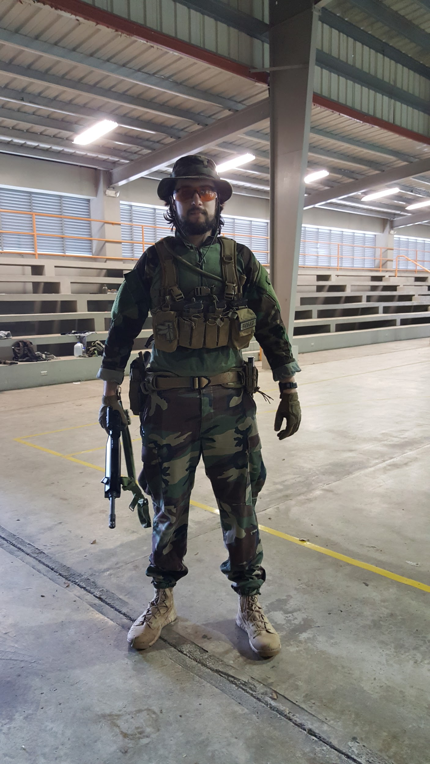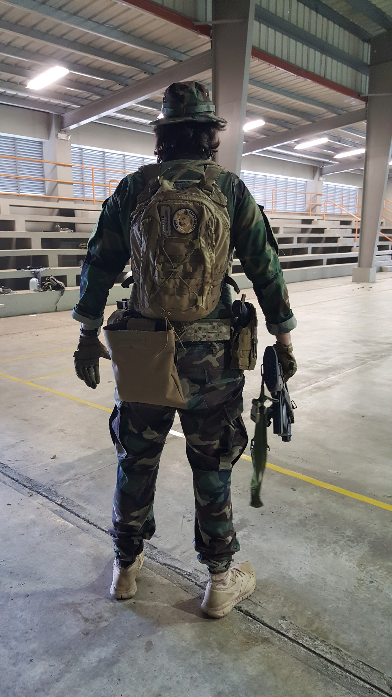

**Constraints and restrictions**

Airsoft in it’s entirety would be very complex to model, it would take a large amount of time and careful planning to represent as a database. For the scope of this project, I’m focusing on the player’s loadout and airsoft gun ownership, with a simplified customization aspecte, and on the airsoft team roster aspect. Temporal databases will not be considered due to deadline constraints. The geographical domain for this is limited only to Puerto Rico, and therefore assumptions are made based on how airsoft is adopted in the island.

Teams

* Team names are unique; there are no duplicate teams, only one team may bear that team name. Lists of existing and previous teams are kept to avoid duplicates
* Ranking is based on overall experience and victories on any kind of game style where competition is involved, whether it’s a milsim event or a standard game.

Members

* All team members are players.
* Players can be members of only one team at a time.
* Team member callsigns are unique within the team. Some are based on the team’s name i.e. a team named Reapers may assign callsigns as Reaper1, Reaper2, and so on.
* Not all players are members of a team.

Players

* Each player’s ID is unique, due to the inevitable possibility of multiple people having the same name, town, and callsign.
* Each player’s ownershipNum is also unique, this is used for both for airsoft gun and loadout ownership.
* It is assumed that a player owns at least one airsoft gun, and has at least one loadout, regardless of it having a secondary airsoft gun or not and of how simple it might be.
* Players can own multiple airsoft guns and loadouts.

Airsoft Guns

* An airsoft gun is owned by at most one player at a time.
* A player can own multiple airsoft guns.
* Serial numbers are unique within the scope of a model for a brand.
* The types and classes are limited to the ones previously specified. Launchers, LPAG (low powered electric airsoft guns), HPA, engine, and Daytona airsoft guns are not considered. AEPs (airsoft electric pistols will be determined by type “AEG” and class “pistol”.
* Binding IDs for attachments, and loadout ticket numbers are unique to an airsoft gun, and do not depend on model or serial numbers.

Attachments

* Attachments are mounted to only one airsoft gun at a time.
* Coincidentally, the attachment on the airsoft gun is also owned by only one player at a time.
* Normally, a model and serial number would be considered for attachments, but in the airsoft market there are multiple items that are “Chinese clones” of real steel items, some of which are “banned” in certain places, thus not all of them have model numbers or serial numbers. These kinds of attachment items will be listed with brand “Repro”.

Loadouts

* A loadout belongs to at most one player at a time.
* A player can have multiple loadouts.
* While more than one player may have the same loadout in terms of having the same airsoft guns and gear, loadouts are considered unique entities.
* A primary airsoft gun is required, while the secondary gun might be listed as NULL if the player lacks one for that loadout.

**Entity/Relation Diagram**

